

AMERICAN INTERNATIONAL UNIVERSITY -BANGLADESH
Department of Computer Science
FACULTY OF SCIENCE and TECHNOLOGY
Program: CSE
Course Name: PROGRAMMING IN PYTHON
SECTION: C

Semester: SPRING 2025-2026 | Date of Submission: 28.03.26

MID PROJECT REPORT
………………………………………………………………………………..

Submitted to
MD. TANZEEM RAHAT
………………….……………………………………………………………

SUBMITTED By:

ID | NAME
21-44425-1 | KHANDKAR MD ANTIK MAHMUD

FOR FACULTY USE ONLY

Faculty comments: …………………………………………………………
Signature: ………………………. Date: ……………………….

STUDENT MANAGEMENT SYSTEM (CLI BASED)
Project overview:
This project is a Student Management System developed using Python. It is a command-line interface (CLI) based application that allows users to manage student records efficiently. The system supports operations such as adding students, updating marks, deleting records, searching, sorting, and displaying student data. The project demonstrates the use of Object-Oriented Programming (OOP), file handling using JSON, and modular programming.
All student data is stored persistently in a JSON file, ensuring that records remain saved even after the program exits.
Setup & Run Steps:
- Python 3.10+ installed and added to PATH
- Install required library:
- Pip install rich
- Ensure both files are present:
- (main.py) & (students.py)
- Run the program:
- (python main.py)

Feature List:

Feature | Details
Add Student | Add new student with name, roll, and marks
Update Marks | Modify marks of an existing student
Delete Student | Remove Student From System
Show All Students | Display all student records in table format
Search Student | Search by exact name or roll number
Sort Students | Sort by roll or marks
Storage | Data saved in JSON file
CLI Interface | Interactive menu driven system
Table Display | Uses Rich library for formatted output

Screenshots:
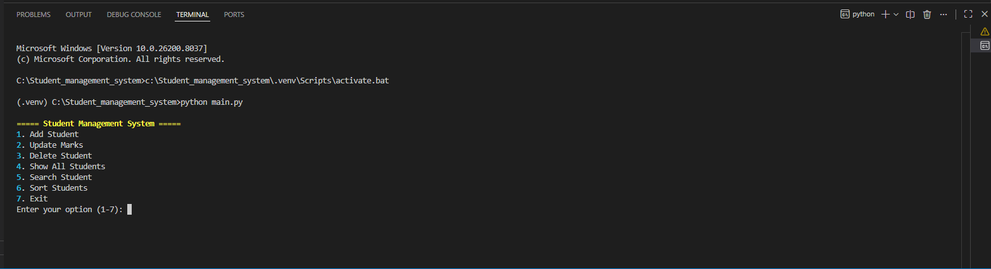
Figure 1: main window

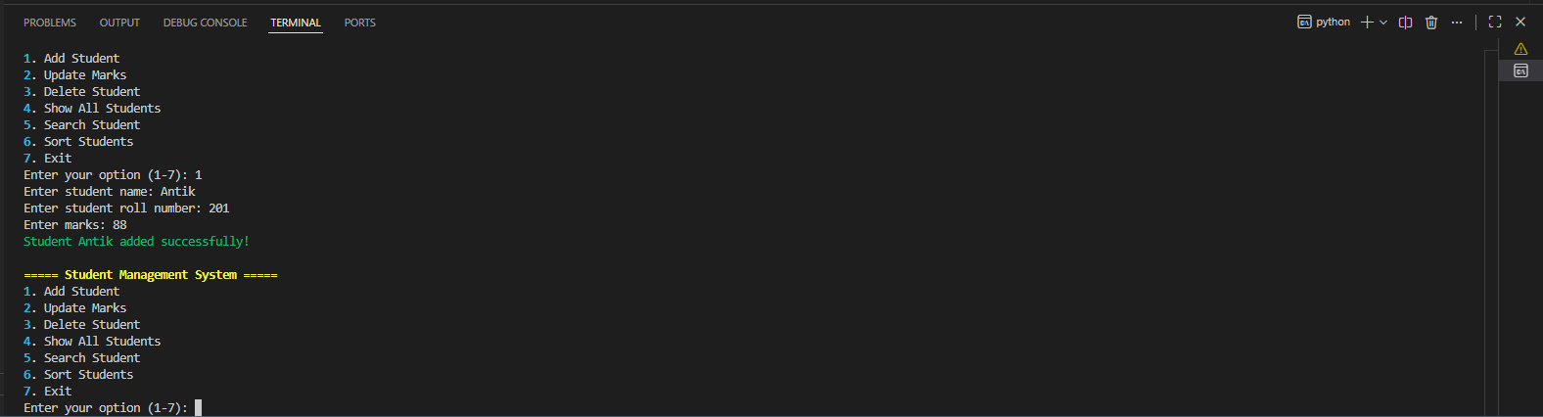
Figure 2: Add Student Input

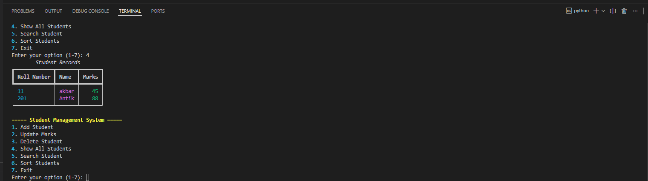
Figure 3: Display Table Output

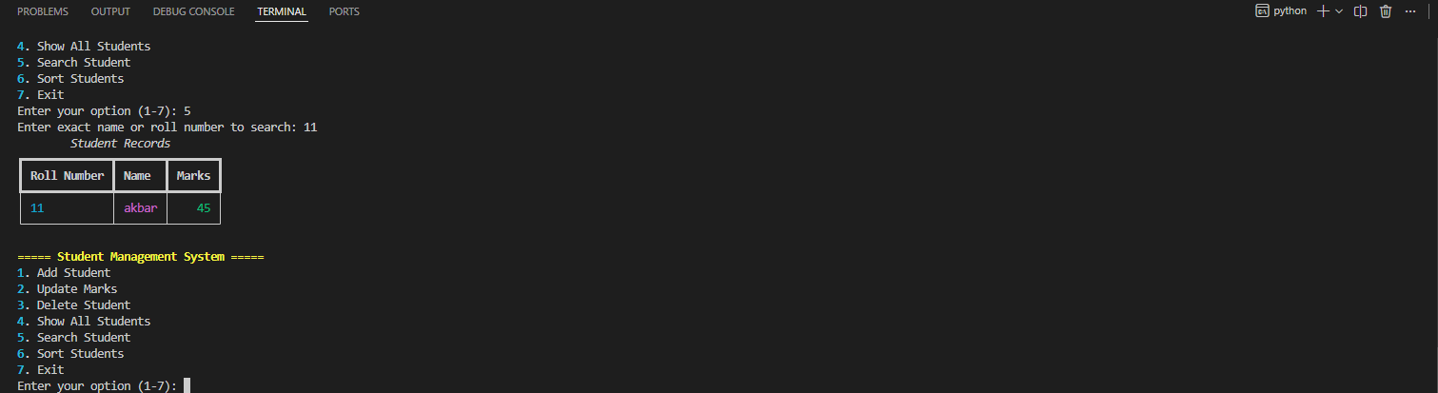
Figure 4: Search Result

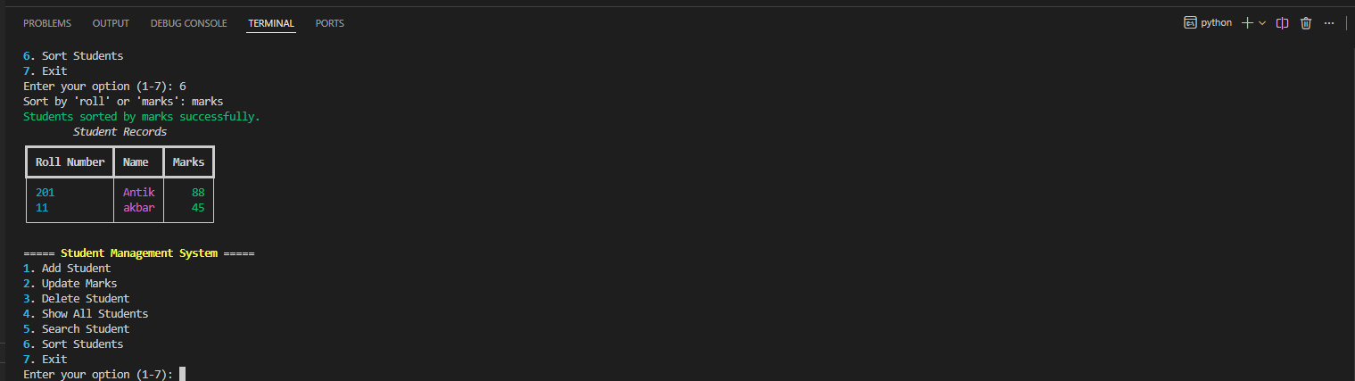
Figure 5: Sort Result

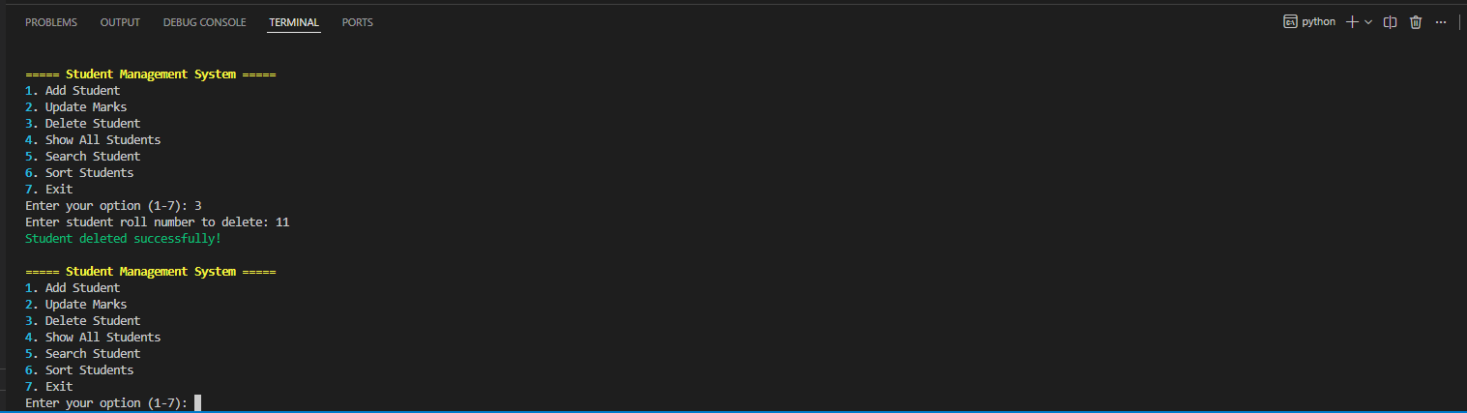
Figure 6: Delete Result

